

17CSC103P

Principles of Web Programming

Planning Analysis Sheet, Site Map, and Wireframes

Project Group: 16

Coordinator TA: Lobna Hesham

Group Leader: Tarek Mohammed

### Members:

|  |  |  |
| --- | --- | --- |
| ID | Student Name | Lab Group |
| 177619 | Tarek Mohammed Mukhtar | A8 |
| 170907 | Youssef Hesham Mohamed | A8 |
| 178244 | Mohamed Hany Abdelwahed | A5 |
| 170009 | Mohamed Kamel Hussein | A5 |
| 155167 | Mohamed Hesham Mohamed | A5 |

**Planning Analysis Sheet:**

**Website Name.**

Now You See Review

**Web site goal?**

This website will assist the user to choose the top products he want by only a click of a button not only by providing him a reviews from a different experienced customer, but also for different type of products, as well as, this website will accomplish the user by providing him with the right reviews and also the flexibility of choosing a review of different products he like.

**What results do I want to see?**

The web page will have five categories

Each category will have 2 to 3 different web pages.

Mobile category will have >IPhone 8 & Samsung S9 & Samsung A8.

Cars category will have >Audi A8 & Toyota Corolla & Ferrari spider.

Movies category will have >Thriller & Action & Comedy.

Books category will have> Action & Romance & Drama.

Consoles category will have>PlayStation 4 & Xbox One.

**What information do I need?**

An Amazon to obtain the price: <https://www.amazon.com/>. We will obtain the text, images, etc. from Cnet :<https://www.cnet.com/> , Techradar: <https://www.techradar.com/> , Tom’s guide: <https://www.tomsguide.com/us/xbox-one-vs-ps4,review-2543.html> , TimeofIndia: <https://timesofindia.indiatimes.com/entertainment/english/movie-reviews> ,Car and Drive: <https://www.caranddriver.com/> , Edmunds: <https://www.edmunds.com/>

**How will your project use a form?**

Offer subscriptions for visitors to a newsletter, so if there is a new product updated to the webpage the visitor will be alarmed through his email. An advanced search to make it easier for the user to move from page to another, as well as, a contact us page to allow the user to comment or tell us if the webpage needs some improvements or contact us for some services.

**Site Map:**

**Wireframe** (from next page because of the width of the page)

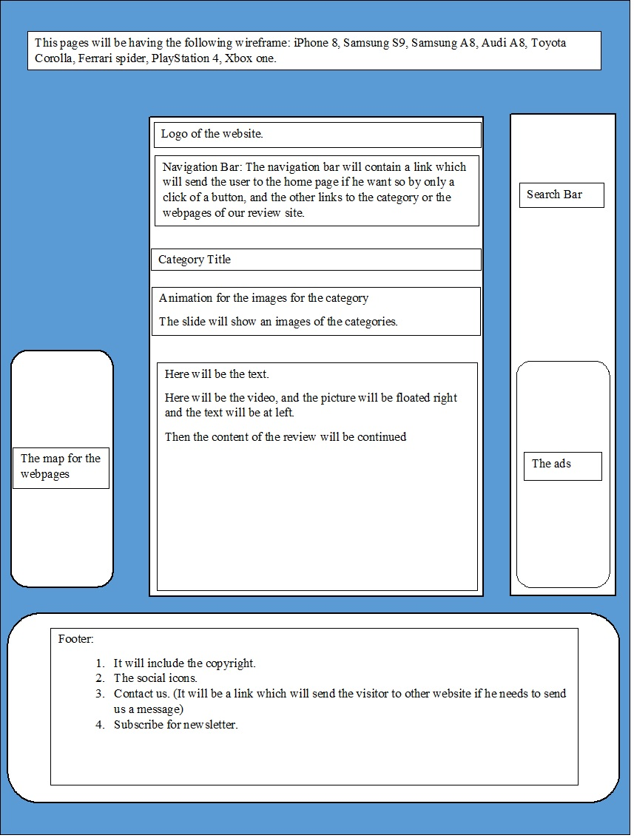

Search Bar

Navigation Bar: The navigation bar will contain a link which will send the user to the homepage if he wants so, by only a click of a button, and the other links to the category or the webpages of our review site.

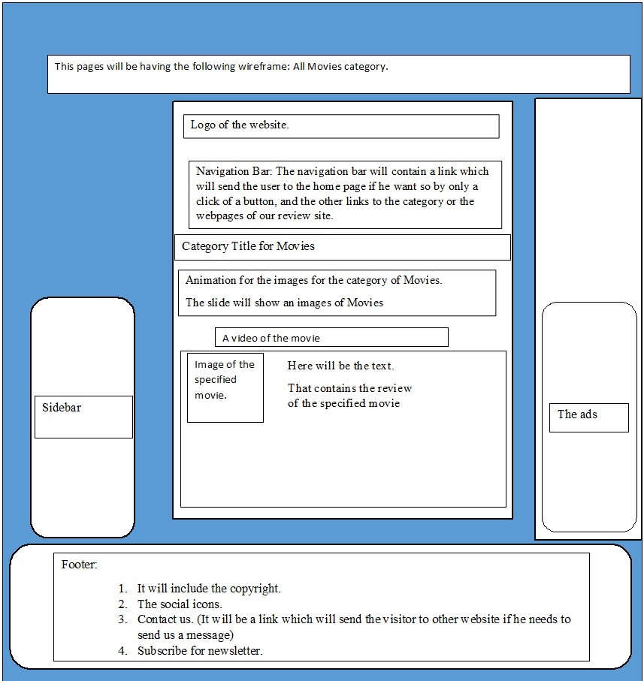

Search Bar

Navigation Bar: The navigation bar will contain a link which will send the user to the homepage if he wants so, by only a click of a button, and the other links to the category or the webpages of our review site.

Search bar

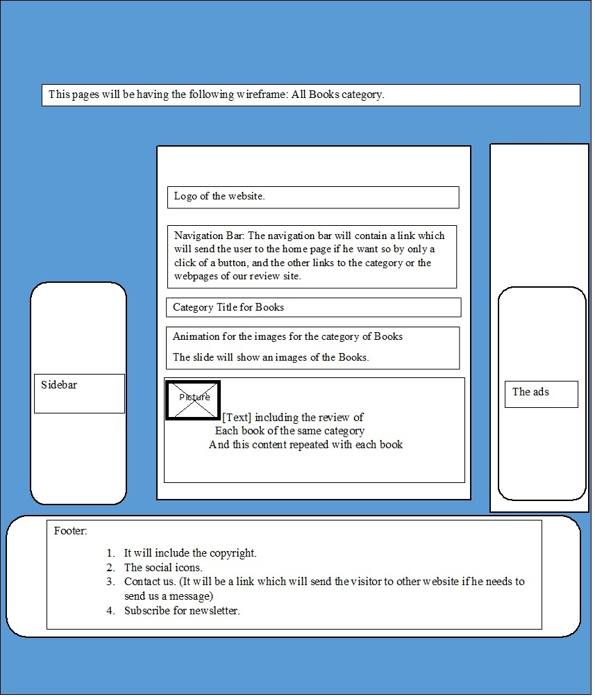

Search Bar

Navigation Bar: The navigation bar will contain a link which will send the user to the homepage if he wants so, by only a click of a button, and the other links to the category or the webpages of our review site.

Search bar

